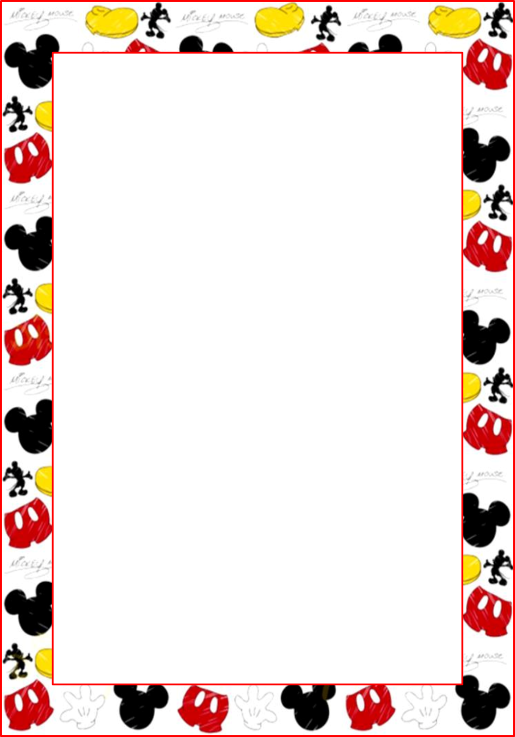

**Welcome to 1st Grade**

**Congratulations**! You are the parent of a first-grader at McBean Elementary School!!!

You will be amazed at just how much your child will grow this year. Most likely, your child

has had the seeds of reading and writing planted, and during first grade, those seeds will grow

and blossom, making your child an accomplished reader and writer! The growth will be

dramatic-just compare a tiny seed with a full-gown sunflower! That’s the kind of growth

you’ll see this year!

I would first like to introduce myself. My name is Shanette Settles. This is my 20th year of

teaching and my 18th year at McBean teaching 1st grade. I graduated from Augusta State in 2004

with a Bachelor’s Degree in early childhood and received a Master’s Degree in Elementary

Education from Southern Wesley University in 2007.

I am looking forward to working with your child this year and helping him/her to achieve his/

her full potential. Throughout the remainder of this newsletter, I will share some of my

expectations and classroom policies and procedures.

**Parent/Teacher Communication**

I believe that a good parent-teacher relationship is necessary for maximum school success.

Throughout the year I will communicate with you through notes, phone calls, newsletters, daily

Behavior reports, conferences, progress reports, and 9 week report cards. If it is not urgent,

please jot a note and I will respond as soon as possible. If needed, you may reach me at

706-592-3723 to leave a message with the secretary or email me

([settlsh@boe.richmond.k12.ga.us](mailto:settlsh@boe.richmond.k12.ga.us)) and I will respond accordingly.

**Changes in Transportation**

If you plan to pick up a child that normally rides the bus or you wish for your child to ride a

different bus than usual, you must send a **written notice** or call the office. If not, your child

will be sent home by his/her usual method of transportation. Car riders will be picked at the

front of school-PLEASE REMAIN IN CAR!!! -and car riders will be called and brought out to you.

**Homework**

Your child will bring home a homework folder each night to be returned each day with

completed homework assignments. Please check folder daily for important information

(ex. notes, field trip information, etc.). If you need to send a note or money please place it in

your child’s folder.

**Snacks**

We will have snacks on Fridays only. Please send in **Smart Snacks** (popcorn, pretzels, granola

bars, pudding, fruit cups, apple sauce, caprisuns, juice box, etc.). I will send home a

reminder with your child when it is your week to send in snacks. **It is important to note that**

**we can NO LONGER celebrate Birthdays with cupcakes or things of that nature.**

**Any questions or concerns regarding this matter, please contact Dr. Dallas.**

**I look forward to a wonderful year of learning!** *Ms. Shanette Settles*

**Reminder:**

We need all children in school daily unless they are sick. Students who are absent from school are **required** to bring a written for their absences the first day back to school (parent or doctor). The school will accept and count 5 days of absents from the parent but others should come from the child’s doctor. **ALL excessive absences and tardies will be reported to DFCS.**

|  |  |  |
| --- | --- | --- |
| **Time** | **Minutes** | **Activity** |
| 8:30 | 10 min. | Record Keeping |
| 8:30-10:00 | 90 min. | ELA/Reading |
| 10:00-10:30 | 30 min. | RTI |
| 10:30-11:20 | 55 min. | Specials (Music, PE) |
| 11:20-12:50 | 90 min. | Math |
| 12:50-1:20 | 30 min. | Lunch |
| 1:20-1:35 | 15 min. | Recess |
| 1:35-2:20 | 45 min. | Science |
| 2:20-3:15 | 55 min. | Social Studies |

**Schedule Subject to Change**

**New student school hours 8:30-3:15**

**Breakfast is 7:45-8:15**



**Welcome to 1st Grade**

**Congratulations**! You are the parent of a first-grader at McBean Elementary School!!! You will be amazed at just how much your child will grow this year. Most likely, your child has had the seeds of reading and writing planted, and during first grade, those seeds will grow and blossom, making your child an accomplished reader and writer! The growth will be dramatic-just compare a tiny seed with a full-gown sunflower! That’s the kind of growth you’ll see this year!

I would first like to introduce myself. My name is Shanette Settles. This is my 16th year of teaching and my 12th year at McBean teaching 1st grade. Previously, I have taught 1st grade for four years at another Richmond County school. I graduated from Augusta State in 2004 with a Bachelor’s Degree in early childhood and received a Master’s Degree in Elementary Education from Southern Wesley University in 2007.

I am looking forward to working with your child this year and helping him/her to achieve his/her full potential. Throughout the remainder of this newsletter, I will share some of my expectations and classroom policies and procedures.

**Parent/Teacher Communication**

I believe that a good parent-teacher relationship is necessary for maximum school success. Throughout the year I will communicate with you through notes, phone calls, newsletters, daily behavior reports, conferences, progress reports, and 9 week report cards. If it is not urgent, please jot a note and I will respond as soon as possible. If needed, you may reach me at 706-592-3723 to leave a message with the secretary or email me ([settlsh@boe.richmond.k12.ga.us](mailto:settlsh@boe.richmond.k12.ga.us)) and I will respond accordingly.

**Changes in Transportation**

If you plan to pick up a child that normally rides the bus or you wish for your child to ride a

different bus than usual, you must send a **written notice** or call the office. If not, your child

will be sent home by his/her usual method of transportation. Car riders will be picked at the

front of school-PLEASE REMAIN IN CAR!!! -and car riders will be called and brought out to you.

**Homework**

Your child will bring home a homework folder each night to be returned each day with

completed homework assignments. Please check folder daily for important information

(ex. notes, field trip information, etc.). If you need to send a note or money please place it in

your child’s folder.

**Snacks**

We will have snacks on Fridays only. Please send in **Smart Snacks** (popcorn, pretzels,

granola bars, pudding, fruit cups, apple sauce, caprisuns, juice box, etc.). I will send home a

reminder with your child when it is your week to send in snacks. **It is important to note**

**thatwe can NO LONGER celebrate Birthdays with cupcakes or things of that nature.**

**Any questions or concerns regarding this matter, please contact Dr. Dallas.**

**I look forward to a wonderful year of learning!** *Ms. Shanette Settles*